Chapter 1 – INTRODUCTION
Below are examples of the various types of headings and text that should be used when preparing an
STO report. Note that the formatting for each of these is stored as a ‘style’ available from the “Styles and Formatting” menu . The following page provides information on to how to populate the information contained in the Headers and Footers using the document PROPERTIES menu.
1.1 STO fIRST LEVEL HEADING
STO text STO text STO text STO text STO text STO text STO text STO text STO text STO text STO text STO text STO text.
1.1.1 STO Second Level Heading
STO text STO text STO text STO text STO text STO text STO text STO text STO text STO text STO text STO text STO text.
1.1.1.1 STO Third Level Heading
STO text STO text STO text STO text STO text STO text STO text STO text STO text STO text STO text STO text STO text.
        - STO Fourth Level Heading
STO text STO text STO text STO text STO text STO text STO text STO text STO text STO text STO text STO text STO text.

Figure 1-1: Enter text.
(STO Figure Caption – appears below the figure)

Table 1-1: Enter text.
(STO Table Caption – appears above the table)

NOTE: http or www Internet addresses appear as ‘dark blue’ text.
- STO Bullet (1st Level)
- STO Bullet (2nd Level)
See following page for “Header/Footer” information
The Headers and Footers in the templates contain specific information about the STO Report and the document itself. In order to automatically generate this information, the following data must be entered into the Document Properties Summary Tab as follows – see Figure 1 and Table below:
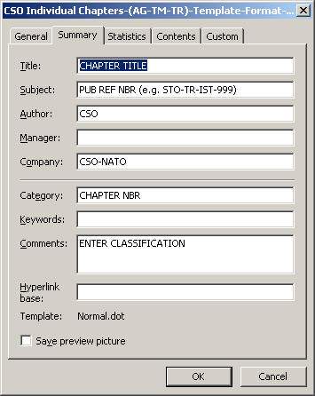
Figure 1: Screenshot of the Document Properties Summary Tab.
(from the Menu: File → Properties → Summary Tab)
Title | Enter the title of the Chapter
Subject | Enter the Report Reference (e.g. STO-TR-IST-999)
Author/  Company | Leave the text as CSO/  CSO-NATO
Category | Enter the Chapter Number as a simple numeric entry (e.g. 1, 2, 3 . . . .)
Comments | Enter the CLASSIFICATION of the Report in CAPITAL LETTERS. This field can be left BLANK if the Report is open for public release

Please note that the Headers and Footers will NOT be visible until you display the document in Print Preview mode (from the Menu: File → Print Preview → Close).
Chapter Nbr – CHAPTER TITLE IN UPPERCASE
Chapter Author’s Name (not obligatory)
Author’s Address (not obligatory)

Start Chapters, Annexes, Appendices here.
Please start each new Chapter, Annex or Appendix on a new page.
Chapter N – REFERENCES

- Please list any references here, numbered as shown.
- Note that the square brackets ([ ]) can be automated using the STO Reference Text style from the Styles and Formatting Menu .

